First and foremost, I want to sincerely thank you both Chris and Crunch.
Without your direct help, intervention, and support over the past couple weeks, my fiancée, AmySue and I, would very likely be back in the hospital—or worse—I may not be alive today. We are both disabled, and since SWAP was activated, AmySue has been ignored multiple times, even while I was in the hospital and emailing the head of it all, asking her to please give my fiancé a voucher when temperatures dropped below 15 degrees. Despite repeated outreach through the SWAP program, she and I are both signed up for, we have been repeatedly ignored, hence why they are also being sued in the Federal courts, and are listed as defendants along with others. Chris and Crunch, you both stepped in when systems failed, and believe me, we have been through every possible program in Colorado and multiple counties since January 2025. I will always be deeply grateful for what you have already done for us.

This proposal requests temporary housing stability and minimal living support through the end of February 2026 so I can safely and reliably complete the CondorBrain / Gaussian integration work already underway with a realistic-anticipated go-live time frame of 4 to 6 weeks from today, provided I am able to continue to work day and night, as I have been since we first met to help this project go from a test project into a real live profitable trading system with institutional-grade analytics and decision making.
Over the past several months, we have experienced repeated wrongful hotel removals based on false smoking allegations, most recently earlier today, despite having fully paid for the room, right after Crunch sent us the money – they effectivelky stole $100.00 deposit + todays room rate of $75.00. In both cases, deposits and nightly charges were retained, police were called, and we were forced onto the street. A similar eviction in October directly led to my 7+ week hospitalization, and shortly thereafter, my fiancée was hospitalized as well, as we are both disabled.
This pattern is not theoretical. It is documented, recent, and dangerous.

Why Stability Is Non-Negotiable
The technical work currently in progress realistically requires 3–5 weeks to complete, possibly an extra week of demo account testing, accounting for:
- final system integration,
- debugging and edge-case resolution,
- tuning and optimization,
- validation and paper-trading readiness.
This work cannot be completed if we are constantly displaced packing, relocating, losing internet access, or recovering from emergency situations. Each forced move costs multiple full development days and introduces significant risk to timely delivery.
In addition, I am actively involved in a federal civil case as you both know. Housing stability is critical so I can receive court notices from the judge in a timely manner. At present, because we are effectively playing “musical chairs” with lodging, I risk missing court communications unless I pay the clerk to email filings—creating delays and procedural risk if a TRO or other court order is issued.

Why Other Resources Have Failed
We pursued outreach, navigation programs, shelters, and 211 referrals, among many others, in good faith. Despite compliance, we were wrongfully removed from Navigation two weeks before permanent housing, triggering the medical crisis that followed. Re-entering those systems has repeatedly failed and presents an unacceptable risk of repeating the same outcome – this is not a viable option to gamble with by any means.

Proposed Solution
A single, continuous hotel placement through the end of February provides:
- physical safety during winter,
- predictable and finite costs,
- reliable internet and workspace,
- uninterrupted development time,
- secure receipt of federal court communications.
This is a finite bridge, not an open-ended request. If Vibra or other defendants are ordered to cover housing, or if permanent housing becomes available sooner, this need is reduced or eliminated. However, without stability now, both the project timeline and our health are at serious risk. In other words, this needs to vbe a rock-solid back-up plan that is put in place effective this coming Wednesday.

Summary of Requested Support
Category | Purpose | Amount
Hotel (Jan–Feb) | Continuous, stable housing | $2,090 @ Baymont Hotel (See screenshot attached)
Food Gap | Non-EBT Food stamp coverage (~14 days @ $30/day) | $420
Transportation | RTD monthly passes (2 people) | $176
One-time Lyft | Transfer to long-term hotel | $14
Total Requested | Stability through end of February | $2,700

Bottom Line
This request is about protecting continuity so I can deliver a near-complete benchmarking system with Chris’ real investor interest behind it—and so my fiancée and I are not placed back into a situation that already nearly cost us our lives.
I am asking for stability, not luxury, and only for the duration necessary to finish the work responsibly, safely, and on time – as I believe in what qwe are doing, and this very well may set all of us up for living a more financially stable life.
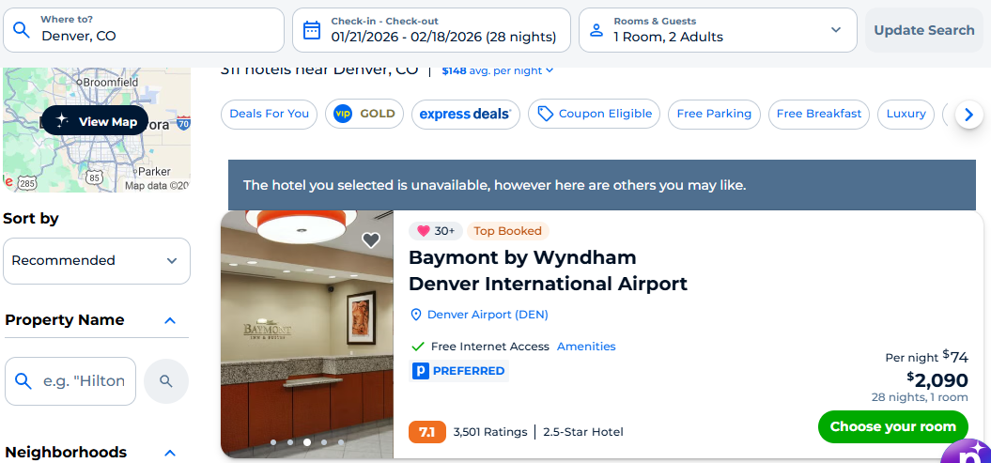
This screen shot shows the total cost if we were to book a room at the Baymont hotel, as this hotel is not continuously available for the entire stay, and the key here is to not constantly have to pack up, push a shopping cart with all of our belongings for however many miles to find another place and keep off the streets where everything I had from before the hospitalization was stolen and caused me to go to the hospital and be resuscitated back to life on November 16, 2025 at approximately 11pm.
In the grand scheme of things for the work I am going to put in to get this done, which requires my non-stop attention day and night, $2700.00 for the upcoming mo9nth is a fraction of what someone would be paid as a contractor to do this level of work with my experience and background in FinTech.
Warm blessings,
T. Jerry Mahabub, Ph.D.

